Updated: October 2020

PRECEDENTS PROJECT SPECIFICATIONS

Product | Litigator 1  Litigator 2  Litigator 3  Litigator 4 (Tax Litigator)
Notes | precedent.dtd is always used  TABLE SPECIFICATIONS FOR ALL SGML DATA is part of these specifications. Only <SGMLTBL> must be provided, and not <ASCIITBL> equivalents for <TABLE> data.

PROJECT OVERVIEW

Precedent documents are selected based on cases published in the specific law reporters.

LITIGATOR TYPE | BUNDLE NUMBERING EXAMPLE | LAW REPORTERS
Litigator 1 | Lit1_Bundle1 | C.P.C., C.C.L.I., C.C.E.L., C.C.L.T.
Litigator 2 | Lit2_Bundle1 | R.P.R., B.L.R.
Litigator 3 | Lit3_Bundle1 | C.C.P.B., C.E.L.R., E.T.R., C.L.R., M.P.L.R., IP Cases
Litigator 4 (Tax Litigator) | Lit4_Bundle1 | C.T.C.

For this project, please do not key page processing instructions within the SGML files.

Please use the precedent.dtd and keydtd.ent to convert this material.
There are no hard copies for this data. Data must be converted from the electronic files provided.

The precedent.dtd contains mark-up for a tag called <COURTFILE>. The <COURTFILE> tag may contain the following elements in any order: <PLEADING>, <MOTION>, <FACTUM> and <ORDER>.

Pleadings: foundational documents that are filed with the court by the parties to a proceeding which set out the issues or matters to be determined by the court.

Motions: requests to the court for an order for the relief or remedy requested which occurs at the court proceeding.

Facta:
- Trial Facta (Submissions) are related to the Trial pleadings.
- Application Facta (Originating) are related to Applications.
- Judgment Appeal Facta are related to Appeals from Trial Judgments.
- Motion Facta (Interlocutory) are related to Motions.
- Motion Appeal Facta are related to Appeals from decisions on Interlocutory Motions.

Orders: decisions of the court or other decision-making body that may or may not be the final outcome of the matter.

REQUIRED TASKS

Task 1: Tag data as dictated by Specifications and DTD

Task 2: Review data to ensure implementation of Privacy Rules

Information to be concealed from publication for privacy reasons has been marked out with a thick black line in the hard copy.

The following type of information has been removed for privacy purposes:
- Personal addresses
- Driver’s license numbers
- SINs
- VINs
- License Plate Numbers
- Health insurance numbers
- Birth certificate numbers
- Passport/Citizenship numbers
- Bank/Credit Card account numbers or any other banking information (loan, mortgage numbers etc.)
- GIC and RRSP numbers (mostly in family cases)
- Private telephone numbers and email addresses
- Medical or psychiatric records entered into evidence (these documents should be removed entirely)

For SGML conversion, key the text that may appear along with the thick black line that states what information was omitted, such as "[address omitted]", "[age omitted]", "[number omitted]" etc.. If no replacement text is provided to, key “[text omitted]”.

Do capture initials if they appear as a text replacement for the thick black lines. If these initials are not captured, it may compromise the meaning of the document.

Task 3: Create PDF Graphic Images of Material

Create PDF image for the content of each <PLEADING>, <MOTION>, <FACTUM> and <ORDER> that represents all pages of the document proper.

Do not include the organizational cover sheets such as Court File Summary Sheet (CFSS), Document Cover Sheet (DCS), etc., or any blank pages.

Do include the back cover pages in the PDF image as they are part of the document even though they are not required for SGML conversion.

Add <GRAPHIC> tag to each <PLEADING>, <MOTION>, <FACTUM> and <ORDER> immediately after the <N> element. <LINKTEXT> within <GRAPHIC tag must always read <LINKTEXT>Original Image of this Document (PDF)</LINKTEXT>.

PDF filename and the attribute needed for the <GRAPHIC> tag must be captured in all caps and composed of the following information:
- Carswell Cite in all caps
- First letter of document type (P for Pleading, M for Motion, F for Factum, O for Order)
- Contents of <N> tag
- .PDF extension

Example: 2020 CarswellOnt 1902, Pleading 1

<GRAPHIC FILENAME="2020CARSWELLONT1902P1.PDF">
<LINKTEXT>Original Image of this Document (PDF)</LINKTEXT>
</GRAPHIC>

KEYING SPECIFICATIONS

PRECEDENT BUNDLES

- Court Filing Documents Collection is a group of documents related to a case published in the law reporter.
- Precedent Bundle may consist of one or more of the Court Filing Documents Collections.
- Carswell Cite is unique to each Court Filing Documents Collection.
- Court File Summary Sheet (CFSS) accompanies each Court Filing Documents Collection and outlines all of the material related to that collection including Carswell Cite the collection belongs to.
- CFSS and Document Cover Sheets (DCS) are considered organizational documents and are not to be converted to SGML.
- Precedent Bundle filename is to be composed of the word "prec" followed by the case’s Carswell cite (all in lower case and without spaces), followed by .key file extension (e.g., prec2020carswellont1234.key).
- Precedent ADD Bundle filename is to be composed of the word "add" followed by the case’s Carswell cite (all in lower case and without spaces), followed by .key file extension (e.g., add2020carswellont1234.key).
- <!DOCTYPE ROOT PUBLIC "-//Carswell//DTD Precedent Keying//EN"> declaration is to be added to the top of each .key file
- Carswell Cite and Style of Cause found in CFSS and CCMS are to be added to each <PLEADING>, <MOTION>, <FACTUM> and <ORDER> within its corresponding Court Filing Documents Collection.

COURT DOCUMENT NUMBERS

- All the documents are required to be numbered and sorted in their chronological order before being added to the SGML file. Running numbers are to be used (e.g., 1, 2, 3, etc.).

GENERAL SUBJECTS

- General Subjects are captured for all Motions, Pleadings and Facta documents in Litigator 1, 2, 3 and 4 (Tax Litigator) Bundles.
- General Subjects are to be found in, and captured from, Carswell Caselaw Management System (CCMS).

General Subjects Search in CCMS
        - Access CCMS: http://appprd.int.carswell.com:8180/alfresco/faces/jsp/login.jsp - InnCLRE1
        - Go to Search tab.
        - Add Citation field on the left.
        - Enter Carswell cite found on the CFSS into that field, hit Enter.
        - Go to DCS (right bottom third of the Search page, scrolled down to see General Subject(s): entry.
        - Use General Subject(s) found in that field as contents of <SUBJECT> tag in every <PLEADING>, <MOTION>, <FACTUM> and <ORDER> of the precedent file.

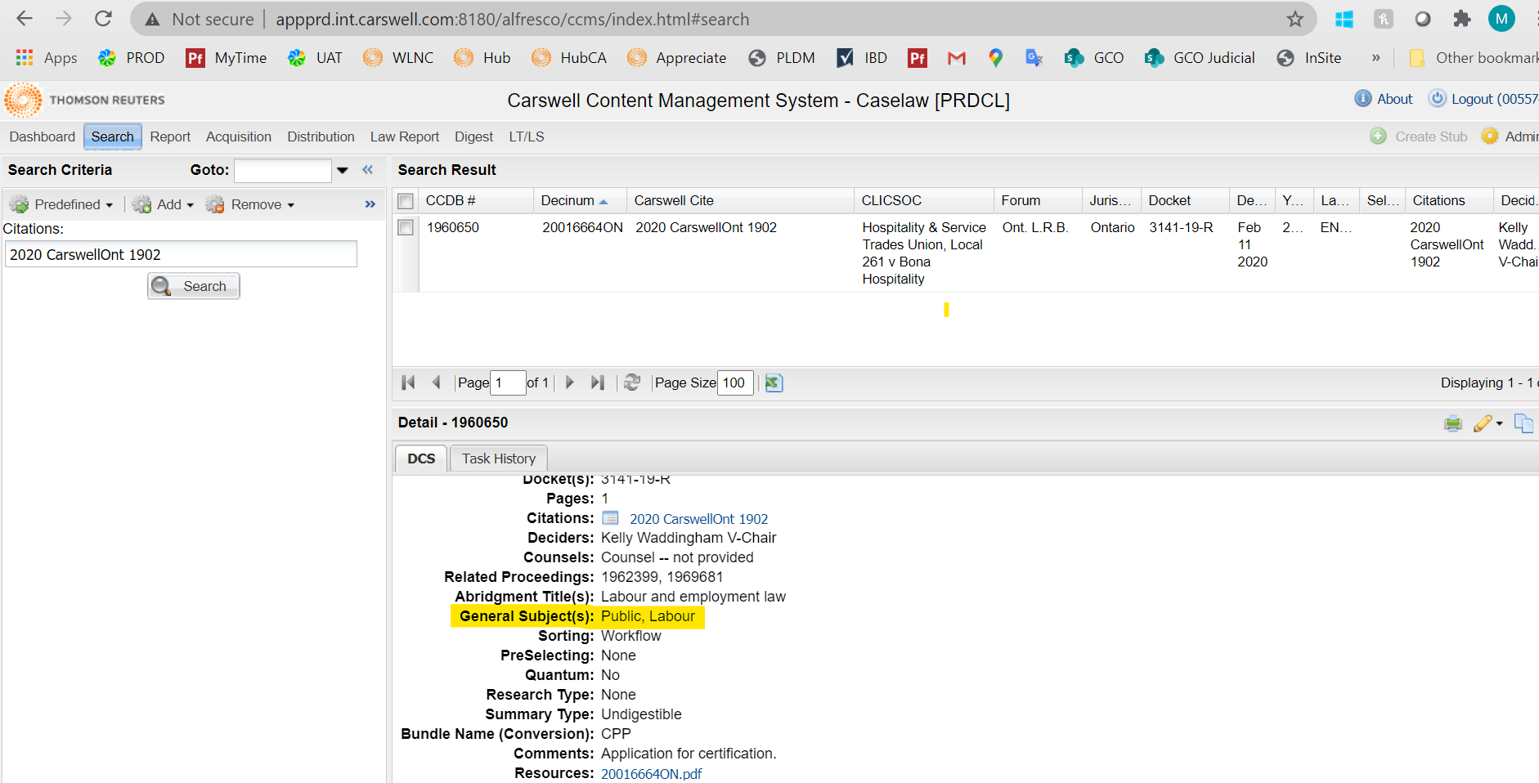

Note: multiple General Subjects are separated by comma. Use as many <SUBJECT> tags for each document as there are General Subjects.

SGML ELEMENTS

COURTFILE

- <COURTFILE> is a container tag for all the <PLEADING>, <MOTION>, <FACTUM> and <ORDER> elements within the same Court Filing Documents Collection.
- ID attribute in <COURTFILE> is based on the Carswell Cite captured without spaces (e.g., <COURTFILE ID="2020CarswellOnt1234">).

PLEADING, FACTA, MOTION, ORDER

The following instructions are common and apply to all four main elements in <COURTFILE>, wherever found and applicable.

- <PLEADING>, <FACTUM>, <MOTION> and <ORDER> elements are used for different types of documents, as indicated on their corresponding DCSs.
- <N> content is a running number assigned to each Pleading depending on its chronological order in the Court Filing Documents Collection, and regardless of their type (e.g., Pleadings, Motions, Facta and Orders may appear in the SGML in any order).

Documents with the same date are to be numbered and placed in the SGML file in the following order:
- Pleadings
- Motions
- Facta/Brief – Motions/Applications
- Facta/Brief – Appeals

- <GRAPHIC> tag requires FILENAME attribute containing Carswell Cite in all caps and without spaces, followed by the contents of <N> tag, with .PDF extension (e.g., 2020CARSWELLONT12341.PDF).
- <LINKTEXT> within <GRAPHIC> is always the same and must read <LINKTEXT>Original Image of this Document (PDF)</LINKTEXT>.
- <DOCTI> contents are to be found in the DOCUMENT TITLE: field on the DCS for each document.
- <SUBJECT> contents are based on the CCMS record of the originated case. See General Subjects Search in CCMS section above for more information.
- <DATE> content is to be found in the original document. The date can appear in the document in any format, full or partial, and must be captured the same way. YYYYMMDD (to reflect Year, Month and Day of the date) and LABEL="Date: " (note the space after the colon) attributes must always be used.

Multiple "date" entries can be found in the document. Pick a date based on what is available in the following order:

- Date marked as "Issue Date".
- If there is no "Issue Date", the date opposite the signature of a judge, registrar or opposite the listing of the lawyers at the end of the document. If there is more than one area within the document that contains the judge’s signature or listing of the lawyers, select the date at the last occurrence of the judge’s signature or listing of the lawyers.
- If none of the above dates is available, capture the date found on the stamp.
- If only a Month or only a Month and Year is provided, and no Date (e.g., “November 2022”), capture Date within YYYYMMDD attribute only as the first of the Month, but keep the contents of the date unchanged. E.g., <DATE YYYYMMDD="20221101" LABEL="Date: ">November, 2022</DATE>.
- If only a Year is provided, and no Month or Date (e.g., “2022”), capture Month and Date within YYYYMMDD attribute only as the 1st of January, but keep the contents of the date unchanged. E.g., <DATE YYYYMMDD="20220101" LABEL="Date: ">2022</DATE>.
- If only a Month or only a Month and Day is provided, and no year, use the year found in the Carswell Cite (e.g., if Carswell cite is 2020 CarswellOnt 1234 and the date in the document is “March 1”, capture <DATE YYYYMMDD="20200301" LABEL="Date: ">March 1, 2020</DATE>.
- In the absence of any date, use the year found in the Carswell Cite as contents of <DATE>, and capture the YYYYMMDD attribute as instructed as the 1st of January (e.g., if Carswell cite is 2020 CarswellOnt 1234, capture <DATE YYYYMMDD="20200101" LABEL="Date: ">2020</DATE>).

All other date information (other than stamps that contain dates, if not used for <DATE> element (see above)) is to be captured where it appears in the body of the document as regular <FREEFORM> text.

EXCEPTION:
Where there is a motion document that includes affidavits, the date should be pulled from the motion document and not the affidavits.
Dates should be pulled from Affidavits if they are included as a document on their own.

- <CASEREF> content is found in the CFSS and must include both the Style of Cause as <SOC> and the Carswell Cite as <CITE>.
        - If Carswell Cite is missing, please query.
        - If Carswell Cite is found but Style of Cause is missing, refer to the CCMS record of the case and use the Full SOC: contents to fill the <SOC> tag.

Note: There may be more than one Carswell Cite listed on the CFSS. Use first Carswell Cite as main citation, followed by as many <CASEREF> tag as there are Carswell cites listed in CFSS, e.g.:

Carswell Cite: 2020 CarswellBC 83, 2020 CarswellBC 1789

<COURTFILE ID="2020CarswellBC83">
<PLEADING LABEL="Pleading" TYPE="Pleading">
<N>1</N>
<GRAPHIC FILENAME="2020CARSWELLBC83P1.PDF">
<LINKTEXT>Original Image of this Document (PDF)</LINKTEXT>
</GRAPHIC>
…
<DATE YYYYMMDD="20020925" LABEL="Date: ">25 September, 2002</DATE>
<CASEREF>
<SOC>3464920 Canada Inc. v. Strother et al</SOC>
<CITE>2020 CarswellBC 83</CITE>
</CASEREF>
<CASEREF>
<SOC>3464920 Canada Inc. v. Strother et al</SOC>
<CITE>2020 CarswellBC 1789</CITE>
</CASEREF>

- <CORRELAT> tag might need to be added to the main and additional <CASEREF> tags. Contents of this tag are to be found in Reporter Citation field on CFSS which may consist of one or more citations. These citations can be provided in full or partial.

Full correlative cites that include reporter volume, reporter name and page number (e.g., 33 C.P.C. 12) must not be captured as <CORRLEAT> tag in the main Carswell Cite (as this data will be added by Thomson Reuters programmatically post-conversion), but converted to partial cite and added as <CORRELAT> tag to the additional Carswell Cite(s) where available and provided.

Partial correlative cites that include reporter name only (e.g., C.P.C.) must be captured as a placeholder within main and additional <CASEREF> elements, where applicable, using <CORRELAT> tag (e.g. <CORRELAT>XX C.P.C. XX</CORRELAT>).

Exception: IP Cases should never be tagged using “XX”, but the wording “IP Cases” (e.g. <CORRELAT>IP Cases</CORRELAT>).

Partial Correlative Cite Provided: | Contents of <CORRELAT>:
C.P.C. | XX C.P.C. XX
C.C.L.I. | XX C.C.L.I. XX
C.C.E.L. | XX C.C.E.L. XX
C.C.L.T | XX C.C.L.T. XX
R.P.R. | XX R.P.R. XX
B.L.R. | XX B.L.R. XX
C.C.P.B. | XX C.C.P.B. XX
C.E.L.R. | XX C.E.L.R. XX
E.T.R. | XX E.T.R. XX
C.L.R. | XX C.L.R. XX
M.P.L.R. | XX M.P.L.R. XX
C.T.C. | XX C.T.C. XX
IP Cases | IP Cases

Example:

Carswell Cite: 2008 CarswellOnt 567, 2007 CarswellOnt 456
Reporter Citation: 45 C.P.C. (6th) 12, C.C.L.I.

ORIGINAL CITE (2008 CarswellOnt 567)

<COURTFILE ID="2008CarswellOnt567">
<PLEADING LABEL="Pleading" TYPE="Pleading">
<N>1</N>
<GRAPHIC FILENAME="2008CARSWELLONT567PA1.1.PDF">
<LINKTEXT>Original Image of this Document (PDF)</LINKTEXT>
</GRAPHIC>
…
<CASEREF>
<SOC>R. v. Dadshani</SOC>
<CITE>2008 CarswellOnt 567</CITE>
<CORRELAT>
<CITE>XX C.C.L.I. XX</CITE>
</CORRELAT>
</CASEREF>
<CASEREF>
<SOC>H. (M.), Re </SOC>
<CITE>2007 CarswellOnt 456</CITE>
<CORRELAT>
<CITE>XX C.P.C. XX</CITE>
</CORRELAT>
<CORRELAT>
<CITE>XX C.C.L.I. XX</CITE>
</CORRELAT>
</CASEREF>
………

Explanation:

Full reporter citation (45 C.P.C. (6th) 12) was not added as <CORRELAT> to the main <CASEREF> as it is a full reporter’s citation. But it was captured in the additional <CASEREF> as partial citation.

Partial reporter cite (C.C.L.I.) was added as <CORRELAT> to both main and additional Carswell cites, 2008 CarswellOnt 567 and 2007 CarswellOnt 456.

IP Cases:

- No reporter cite would ever be provided for IP Cases. Instead, Reporter Citation field on the CFSS would read
“IP Cases” and this must transform into <CORRELAT><CITE>IP Cases</CITE></CORRELAT>.

If NO reporter cite is provided, please query.

- *****START OF COURT DOCUMENT***** must be added as the first <DOCKET> level in every Pleading of a court file. A total of 5 asterisks must be captured before and after the text. A LABEL is not required. <DOCKET>*****START OF COURT DOCUMENT*****</DOCKET> must never be placed as part of a <CASEREF>.
- <DOCKET> contents must be found in the document. Docket(s) generally appear in the right top corner of the first page of the document. Only Docket number must be included in the <DOCKET> tag. This <DOCKET> must be placed directly after the “START OF COURT DOCUMENT” <DOCKET>.

LABEL attribute within <DOCKET> must consist of all the prose text associated with the docket. The text may need to be moved to appear before the docket number. Note that a space must be included at the end of the LABEL attribute to represent the space required between text or punctuation and the content that follows.

If Docket is not found in the document, check CCMS, Docket field and capture it as it appears in the CCMS record.

There may be multiple Dockets in the document, all of them would be required to be captured one after another.

In rare instances, when Docket number(s) cannot be found in either of the above source, capture Docket number not indicated.

Examples:

Court File No. 02-CV-232567SR
No. S004562 Vancouver Registry
Appeal No. C38411

<DOCKET>*****START OF COURT DOCUMENT*****</DOCKET>
<DOCKET LABEL="Court File No. ">02-CV-232567SR</DOCKET>
<DOCKET LABEL="Vancouver Registry No. ">S004562</DOCKET>
<DOCKET LABEL="Appeal No. ">C38411</DOCKET>

Example:

No Docket information is provided

<DOCKET>*****START OF COURT DOCUMENT*****</DOCKET>
<DOCKET>Docket number not indicated.</DOCKET>

- <COURTJUR> most often appears centered on the first page of the Pleading below the docket number. Capture the casing of the court information exactly as it appears on the hard copy. Do no capture any bold or italic appearance.

If <COURTUR> is not provided or cannot be found in the document, check CCMS record, Forum field. Note, the Court Name in that field is provided in its abbreviated form. For the expanded Court Names, see Court Names.xls (sent separately)

- <PARTYBLOCK> data or data related to parties of the case may appear as centered, flush right and flush left text on the first page of the document below the court information OR the party information may appear on the front or back page of the document but be formatted in a different manner.

Please do your best to populate <PARTY> and <PARTYROLE> elements when the information is provided somewhere in the document.

There are multiple pieces to the <PARTYBLOCK>. Elements within <PARTYBLOCK> may need to be repeated where there are multiple parties to a case. Capture the casing of the party information exactly as it appears on the hard copy. The entire <PARTYBLOCK> may need to be repeated, but only do this where there is a second occurrence of the text "BETWEEN" or other similar text isolated on a single line that links multiple adversarial blocks of text.

Once all <PARTYBLOCK> information has been captured, if the same data appears later in the document, use <TABLE> tagging to capture it.

If <PARTYBLOCK> information is not provided within the document, refer to the CCMS record and use Full SOC to identify the parties.

Examples:

Multiple <PARTYBLOCK> elements

<PARTYBLOCK>
<LINE>BETWEEN:</LINE>
<PARTY>TAMMY BYERS, by her Litigation Guardian DAVID BYERS, GAIL BYERS and the said DAVID BYERS</PARTY>
<PARTYROLE>Plaintiffs</PARTYROLE>
<CONNECTOR>&mdash;and&mdash;</CONNECTOR>
<PARTY>PENTEX PRINT MASTER INDUSTRIES INC., DOSEY GEORGE BLACK, and CANADIAN PROFESSIONAL ENGRAVERS ASSOCIATION INC.</PARTY>
<PARTYROLE>Defendants</PARTYROLE>
</PARTYBLOCK>

<PARTYBLOCK>
<LINE>AND BETWEEN</LINE>
<PARTY>CANADIAN PROFESSIONAL ENGRAVERS ASSOCIATION INC.</PARTY>
<PARTYROLE>Plaintiff by Counterclaim</PARTYROLE>
<CONNECTOR>&mdash;and&mdash;</CONNECTOR>
<PARTY>GAIL BYERS and HI-TEK ENGRAVING SUPPLIES INC.</PARTY>
<PARTYROLE>Defendants to the Counterclaim</PARTYROLE>
</PARTYBLOCK>

Multiple <PARTY> elements

<PARTYBLOCK>
<P>IN THE SUPREME COURT OF BRITISH COLUMBIA</P>
<LINE>BETWEEN:</LINE>
<PARTY>THE CONTINENTAL INSURANCE COMPANY OF CANADA</PARTY>
<PARTYROLE>DEFENDANT / PLAINTIFF BY COUNTERCLAIM </PARTYROLE>
<CONNECTOR>AND:</CONNECTOR>
<PARTY>INTERNATIONAL COMMODITY TRADERS LTD.</PARTY>
<PARTYROLE> PLAINTIFF / DEFENDANT BY COUNTERCLAIM</PARTYROLE>
<CONNECTOR>AND:</CONNECTOR>
<PARTY>RALPH LANUZEL, GEORGE LAWRENCE BURDEN, and 379785 B.C. LTD. Doing business as COASTAL FOREST PRODUCTS.</PARTY>
<PARTYROLE>DEFENDANTS BY COUNTERCLAIM </PARTYROLE>
</PARTYBLOCK>

<PARTYBLOCK> CONTENTS
COMMON TEXT  (if applicable) | APPEARANCE ON HARD COPY | SGML ELEMENT | JURSIDICTION
"IN THE MATTER OF" | Centred | <P> | All
"BETWEEN" | Flushed Left | <LINE> | All
name or group | Centred | <PARTY> | All
"Plaintiff" | Flushed Right | <PARTYROLE> | All
"-and-" | Centred | <CONNECTOR> | All
name or group | Centred | <PARTY> | All
"Defendant" | Flushed Right | <PARTYROLE> | All
"Brought under…"  “Proceeding under…"  "Application under…" | Centred | <ACTUNDER> | B.C., Ont.

- <COUNSELBLOCK> is a container for authoring lawyer(s) information.
- If authoring lawyer information cannot be found in the original document, refer to the CCMS record of the case, Counsels field.
- <COUNSELBLOCK> is to be composed using the information about authoring lawyer or counsel and not the lawyer or counsel information to whom the document is directed to. Counsel information beginning with "TO:" or "AND TO" is not the authoring counsel information. Information beginning with "TO:" or "AND TO" is to be captured as <FREEFORM> text where it appears in the document.

The authoring counsel information is generally found at the end of the document often opposite the issue date but it may appear closer to the beginning of the document or on the back cover page of the document. The back cover page is a good place to double check authoring lawyer information and to clarify any specific details.

<COUNSELBLOCK> elements:
- <LAWFIRM> element is required. It must contain <FIRMNAME> (to capture the name of the law firm) and optionally <FIRMTYPE> (to capture the law firm type, if provided, e.g., Barristers and Solicitors).

Sole Practitioners (lawyers working under their own proper names) are to be captured as both <FIRMNAME> and <COUNSEL>. Where there is no <FIRMNAME> but there is <COUNSEL> information, repeat the name of the <COUNSEL> within the <FIRMNAME> (not including the detailed tagging breakdown required within <COUNSEL> that is not supported within <FIRMNAME>).

Example (British Columbia authoring lawyer information that appears as a prose paragraph from which the appropriate information must be extracted for fielding purpose):

THIS STATEMENT OF DEFENCE is filed by C.A. Morton, Solicitor for the Defendant, whose place of business and address for delivery is 800 – 808 Nelson Street, Vancouver, British Columbia, V6Z 2L5 [File No: 2222662; Unit Leader: Claudia Orieux (662-5404)].

SGML:
<COUNSELBLOCK>
<LAWFIRM>
<FIRMNAME>C.A. Morton</FIRMNAME>
</LAWFIRM>
<ADDRESS>
<LINE>800 - 808 Nelson Street,</LINE>
<LINE>Vancouver, British Columbia</LINE>
<LINE>V6Z 2L5</LINE>
</ADDRESS>

<COUNSEL><FIRSNAME>C.A.</FIRSNAME><LASTNAME>Morton</LASTNAME></COUNSEL>
<LINE>File No: 222662</LINE>
<LINE>Unit Leader: Claudia Orieux (662-5404)</LINE>
</COUNSELBLOCK>

- <ADDRESS> element is optional. Where used, it must consist of <LINE> elements. New <LINE> element should be used within <ADDRESS> for the following information:
  - number and name of the street
  - city and province
  - postal code
  - any additional address information provided.
- <COUNSEL> is a container for <TITLENAME>, <FIRSNAME>, <LASTNAME> and <DESIGNAT>.
- <TITLENAME> is to capture any designations such as Mr., Ms., Mrs., Miss, etc.
- <FIRSNAME> is to capture given names or given initials of the counsel that precede the surname of the counsel.
- <LASTNAME> is to capture the counsel’s surname.
- <DESIGNAT> is to capture any designation information attached to the counsel name, such as "Q.C.", "LL.B", etc.

Sole Practitioners (lawyers working under their own proper names) need to be captured as both <FIRMNAME> and as <COUNSEL>. Where there is a <FIRMNAME> and no <COUNSEL> and the <FIRMNAME> is the proper name of a person, repeat the <FIRMNAME> information within <COUNSEL>.

Example (Ontario authoring lawyer information that appears in the hard copy as a set of individual lines):

MAURICE W. PILON
Barriser & Solicitor
505 Ellesmere Road, Suite 3
Scarborough, Ontario
M1R 4E5
(416) 752-0720
(416) 752-1439 (Fax)
Plaintiff's Solicitor

SGML:
<COUNSELBLOCK>
<LAWFIRM>
<FIRMNAME>Maurice W. Pilon</FIRMNAME>
<FIRMTYPE>Barrister & Solicitor</FIRMTYPE>
</LAWFIRM>
<ADDRESS>
<LINE>505 Ellesmere Road, Suite 3</LINE>
<LINE>Scarborough, Ontario</LINE>
<LINE>M1R 4E5</LINE>
<LINE>(416) 752-0720</LINE>
<LINE>(416) 752-1439 (Fax)</LINE>
<LINE>Plaintiff's Solicitor</LINE>
</ADDRESS>

<COUNSEL><FIRSNAME>Maurice W.</FIRSNAME><LASTNAME>Pilon</LASTNAME></COUNSEL>
</COUNSELBLOCK>

To prevent parsing errors when data is returned, do not key any hard returns between tags within <COUNSEL> but run the tags together in-line.

- <LINE> may contain any additional information that follows the counsel name such as phone numbers, fax numbers, "LSUC" numbers, any text, e.g., "Solicitor for the Plaintiff", etc. Each separate line of numbers and text must be placed within its own <LINE> tag.

<COUNSELBLOCK> may need to be repeated where the authoring lawyers are from more than one Firm and where separate <LAWFIRM> and <ADDRESS> information needs to be captured. Ensure that only authoring lawyer information is captured when repeating this tag and not the lawyers to whom the documents are directed to.

- <FREEFORM> element is a container for Pleading, Motion, Factum or Order. Usually, <FREEFORM> begins with the centered title on the first page. See GENERAL INSTRUCTIONS for further direction regarding <FREEFORM> text and appearance of text guidelines.

Elements to be used within <FREEFORM> as needed:
- <BLOCK1><TI> for centered headings (use <BLOCK0><TI> before <BLOCK1><TI> if it is necessary to capture two sets of centered headings).
- <BLOCK2><TI> for flushed left headings.
- <BLOCK3><TI> for flushed left headings nested within <BLOCK2>.
- <BLOCK4><TI> for flushed left headings nested within <BLOCK3>, etc.
- <P> for flushed left text.
- <P1> tags for indented text.
- <NP><N><P> for numbered paragraphs where all of the paragraphs within the <FREEFORM> are numbered.
- <LINE> tags for non-itemized lists and entries within an address.
- <ITEM><P> within <P> for lists with bullets or m-dashes. Do not key bullets or m-dashes within <ITEM> as are automatically generated post-conversion.
- <APPENDIX> for Schedules, etc. at the end of documents.
- <GRAPHIC> for images within the SGML files that cannot be easily captured using SGML tagging as either a table or within freeform tagging.

The following are requirements for capturing graphics as .BMP images and their SGML element placeholders:

- Graphics are be scanned at 300 dpi.
- .BMP file name must:
- Unique.
- Appear in all caps and be composed of Carswell Cite (without word "Carswell"), followed by sequential number, with a .BMP extension. There is no character limit for the .BMP files.
Example: four .BMP images in 2004 CarswellOnt 1902 would be 2004ONT19021.BMP, 2004ONT19022.BMP, 2004ONT19023.BMP, 2004ONT19024.BMP.
- <GRAPHIC> tag for each .BMP file must be added to the appropriate SGML file. The .BMP file name is to be used as GRAPHIC FILENAME attribute.
- Each <GRAPHIC> tag must be nested withing its own <P> element.
- <GRAPHIC> element must include <LINKTEXT> tag that consists of the word "Graphic" followed by sequential number that matches the .BMP filename number assigned to that graphic (e.g., “Graphic 1”, “Graphic 2”, etc.).
Example:
<P><GRAPHIC FILENAME="2004ONT19021.BMP">
<LINKTEXT>Graphic 1</LINKTEXT>
</GRAPHIC></P>
PLEADING

- LABEL attribute in <PLEADING> is always <PLEADING LABEL="Pleading">.

FACTUM

- LABEL attribute in <FACTUM> is always <FACTUM LABEL="Factum">.
- TYPE attribute in <FACTUM> must be captured in all caps. Based on DOCUMENT CATEGORY field on DCS, capture FACTUM TYPE attribute as following:
- FACTA/BRIEFS – APPEALS is always <FACTUM LABEL="Factum" TYPE="STANDALONE">
- FACTA/BRIEFS – MOTIONS is always <FACTUM LABEL="Factum" TYPE="INTERLOCUTORY">
- FACTA/BRIEFS – APPLICATIONS is always <FACTUM LABEL="Factum" TYPE="PLEADINGFACTUM">.

ORDER

- LABEL attribute on <ORDER> is always <ORDER LABEL="Order">.

MOTION

- LABEL attribute on <MOTION> is always <MOTION LABEL="Motion">.

GENERAL INSTRUCTIONS

Handwritten Text

All handwritten markup and pages within a document must be reviewed and analyzed. Some, but not all, of this handwritten content needs to be captured.

- DO NOT CAPTURE handwritten text if it is:

  - Judges' or authors’ notes or comments on a typewritten document (See example at Schedule “A”).
  - Text at the top of amended documents such as "This claim was amended pursuant to an order" or "Amended this 18th day of May". (Note: if this information appears in a stamp, it is also not to be captured) (See example at Schedule “B” below).

- DO CAPTURE handwritten text if it is:

  - Handwritten dates and docket numbers.
  - Handwritten text that attempts to correct/clarify illegible typewritten text.
  - Handwritten text that attempts to remove, change or add to typewritten text and is marked with initials indicating that the change is authorized by the author or affiant (See example at Schedule “C” below). If there are no initials, ignore the handwritten text.
  - Handwritten text that forms all or part of an Order, including handwritten Orders on a back cover page (See examples at Schedules “D” and “E” below).
  - Hand- or typewritten initials that have been added above privacy text struck out with a thick black line.
  - Documents that are completely handwritten (See example at Schedule “F” below).

If you have any questions about capturing handwritten data, please query.

Illegible Text

- For in-line text where some of the text can be read but other text cannot, add "[Illegible text]" to represent the illegible text.
- For entire paragraphs that are illegible, add <P>[Illegible text]</P>.

Missing Text

- Add "[Missing text]" if:

  - In-line text begins or ends abruptly. (See examples at Schedules “G” and “H” below).
  - Pages are missing (See example at Schedule “I” below).

- Do not add “[Missing text]” if paragraphs are not sequentially numbered. The missing or additional paragraph numbers may reflect a version change.

Bad Pages

If bundles contain any pages that are distorted and cannot be captured using the OCR process, the content on these pages must be keyed, or the BMP image created.

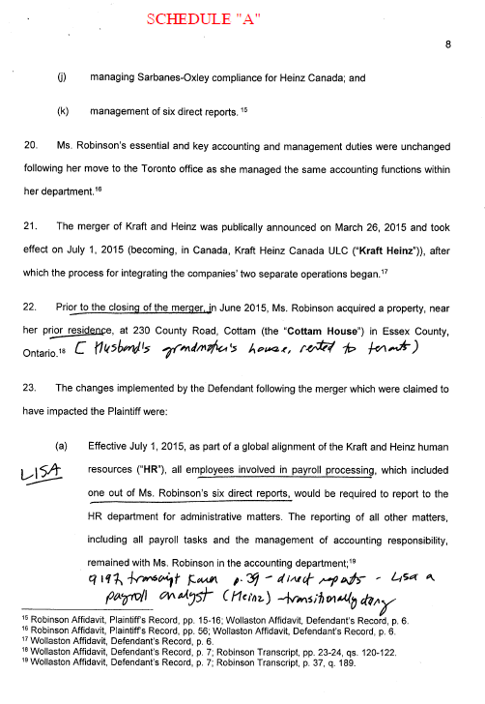

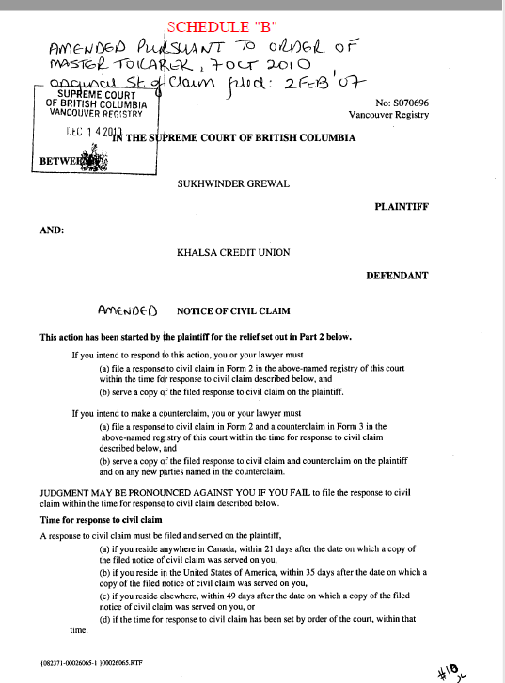

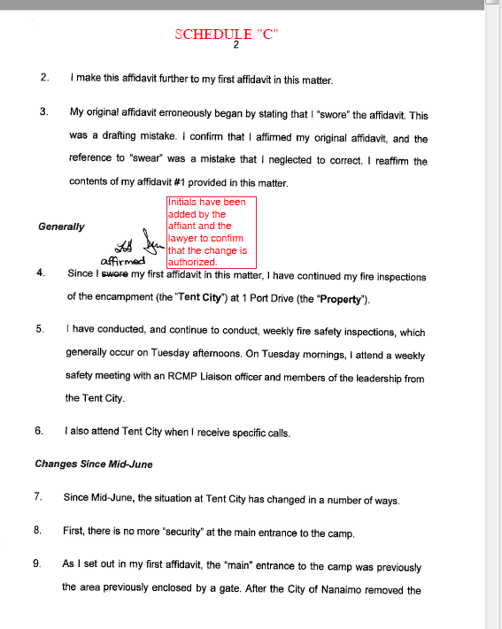

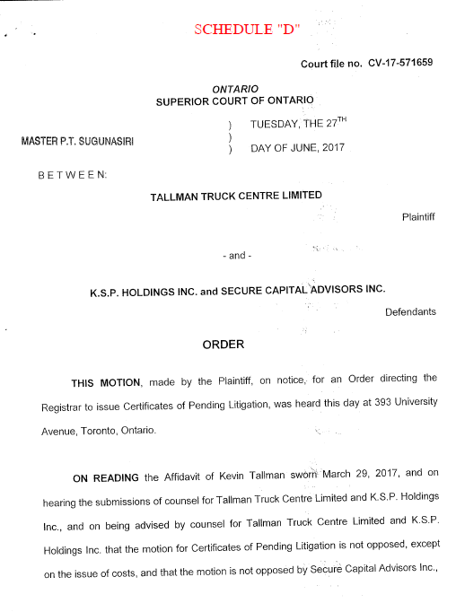
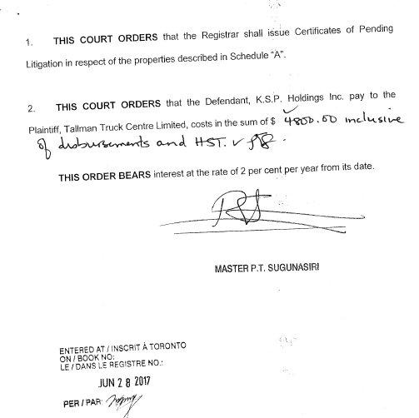

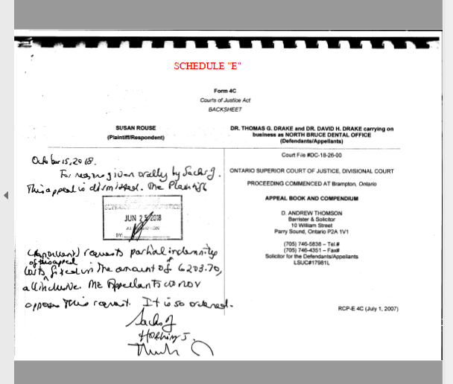

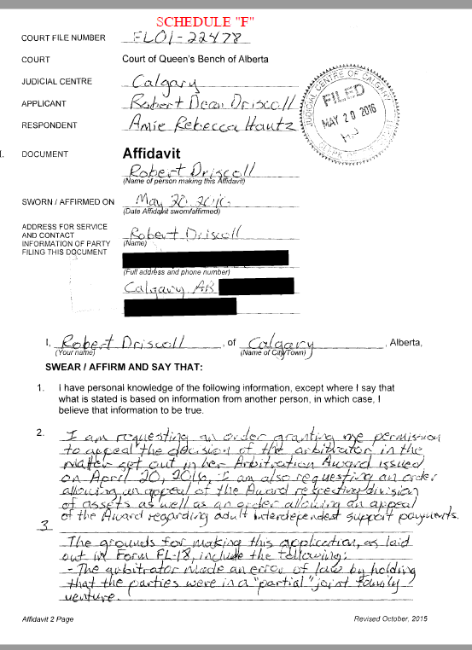

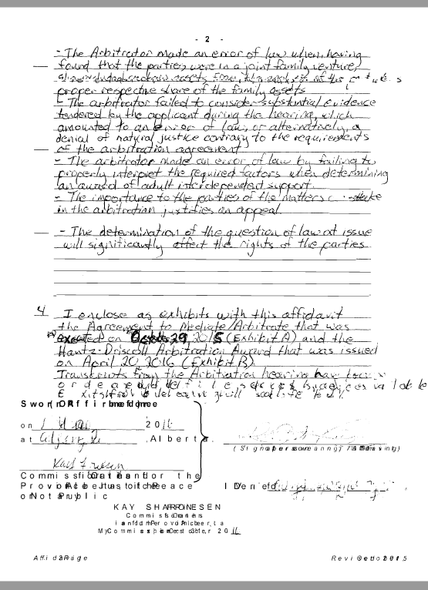

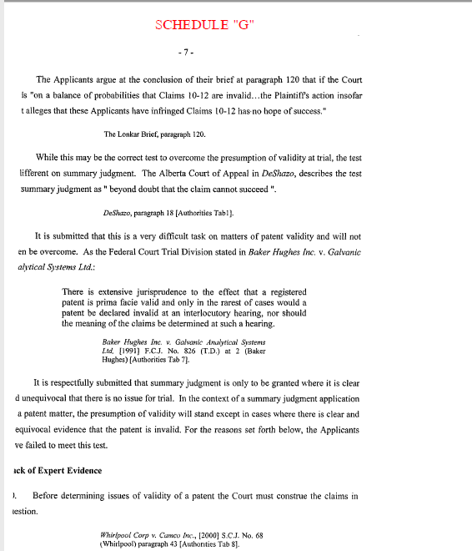

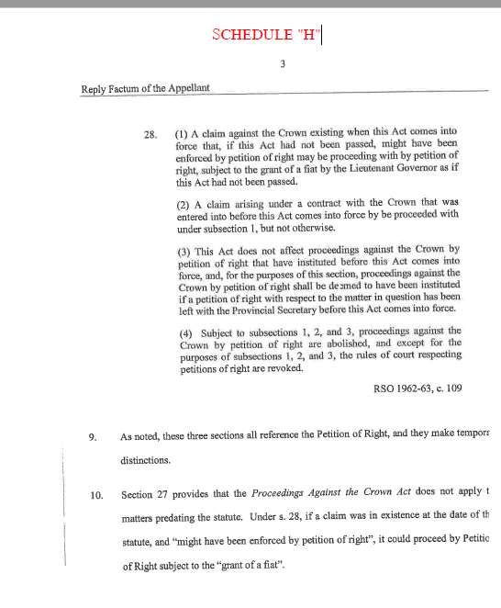

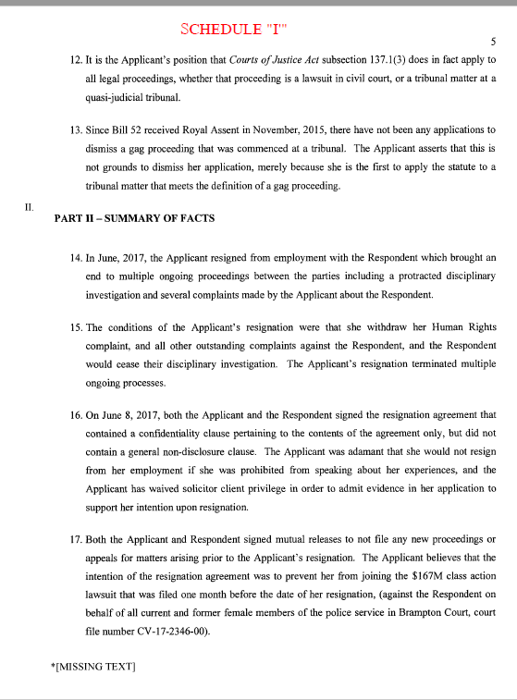

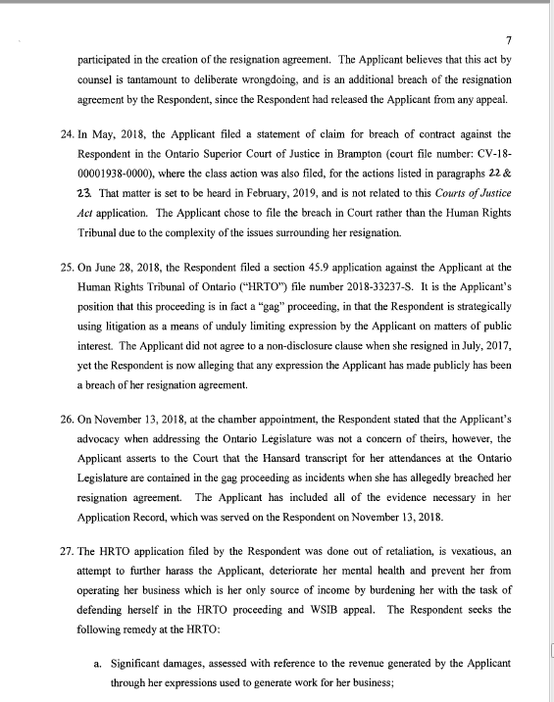

Tables of Content, Indices etc.
- For this data, do convert Tables of Content, Indices etc. to capture the documents in their entirety.

Tables
- See TABLE SPECIFICATIONS FOR ALL SGML DATA for table tagging.
- <TABLE> tag should be used sparingly. It is intended only for chart-like or columnar data.
- <TABLE> tag must be used for material that contains "brackets down the middle". These often appear in the <ORDER> element.

Example 1:

THE HONOURABLE ) THURSDAY THE 3RD DAY
)
MADAM JUSTICE PEPALL ) OF JULY, 2003

Example 2:

SWORN BEFORE ME at the City of )
Vancouver, in the Province of British )
Columbia, this 28th day of June, 2001. )
)
A Commissioner for taking Affidavits ) Gregory B. Maffei
for British Columbia

Example 3:

SWORN BEFORE ME in the City of )
Toronto, in the Province of Ontario, )
this 16th day of April, 2003. )
)
A Commissioner, etc. ) David Ritchie

Editorial Notes
- <EDITNOTE> tag is to be used for editorial notes. This tag does not generate text or brackets.
- <EDITNOTE> tag allows <FREEFORM>.
- If <EDITNOTE> is used within <TI> that contains existing text, key the &nbsp; entity at the beginning of the <EDITNOTE> so the editorial note text does not run into the title text. If the <TI> tag is empty (i.e. the title content has been repealed and there is nothing left in the <TI> tag) do not use the &nbsp; entity within the <EDITNOTE>.
- Do not use <EDITNOTE> within <TABLE>. Place it outside of the <TABLE> or use <TBLNOTES> tagging, if appropriate.

Footnotes
- <FOOTNOTE> tag is used for footnote.
- Always key a space following the closing </FOOTNOTE> tag (unless it is followed immediately by another closing tag).
- <FOOTNOTE> tag allows <FREEFORM>. Place the body of the footnote within <P> tags.
- <FOOTNOTE> tag also allows an optional <N> tag which should not be used for this data unless specifically requested to do so for a particular bundle.
- <N> tag within <FOOTNOTE> should only be used where expressly requested in the specifications for particular data (i.e. where standing footnote numbers need to be retained).
- Do not key the footnote symbol such as an asterisk ( * ) or dagger ( † ). For output, footnote numbering or footnote popups will be generated as required.
- Do not use <FOOTNOTE> within <TABLE>. Use <TBLNOTES> tagging instead.
- <FOOTNOTE> tag may be used within <TI> but must appear at the very end of the element.
- <FOOTNOTE> tag may not nest inside itself.

Quoted material
- <QUOTE> tag is used to capture quoted material that cam most often be distinguished by indentation or a change in font.
- Do not key &ldquo; and &rdquo; around the entire contents of <QUOTE>. Use <QUOTE> tag to indicate quoted text. In-line words or phrases within the <QUOTE> tag may require the use of &ldquo; and &rdquo;.
- Do not use the <QUOTE> tag to "fit in" data that does not seem to conform to a normal structure or expected numbering style.
- Legislative tagging must be used within <QUOTE> for quoted legislation.

Emphasized text
- <EM> tags are used to capture in-line content that has been italicized to stand out from surrounding text.
- Do not:
- include end punctuation for a sentence or phrase within <EM> tags.
- use <EM> within <CASEREF><SOC> tags or any other case names found in the documents.
- use <EM> to surround <EDITNOTE>.
- surround the entire contents of a legislation tag with <EM>.
- use <EM> within <TERM> tags.

Infra and Supra Text
- The italic text "supra" and "infra" often follow an abbreviated style of cause reference that also appears in italic. The italic text "supra" and "infra" should be tagged within their own <EM> tags when they follow other italicized text (e.g., <EM>Smith</EM>, <EM>infra</EM> rather than <EM>Smith, infra</EM>).
- Note that if "supra" and "infra" follow a complete style of cause as defined under "Case References" below, the italic text "supra" and "infra" should be tagged within <EM> tags but the complete style of cause must be tagged as <CASEREF><SOC>. For example, <CASEREF><SOC>Smith v. McAlpine</SOC></CASEREF>, <EM>infra</EM>.

Case References
- <CASEREF> tagging is used for case references across all data. Do not use <CASEREF> within <TI> tags.
- <SOC> element must include Style of Cause that may appear in the document as follows:
- Two parties separated by "v." or "c."
- One party followed by ", Re"
- One or more parties beginning "In the Matter of" or "In Re"
- <JUDGDATE> is used for capturing judgment date where available. Do not key parenthesis, if added.
- <DOCKET> tag is for Docket numbers, if provided.
- <YEAR> is used for capturing a year, usually in reported cases. Do not key parenthesis that may surround the year.
- <CITE> is used to capture main citation (or first cite listed) within the case reference. DO NOT use <SUP> or <SUB> tags within <CITE>.
- <PAGENUM> tag is used to capture any "at" references that may follow <CITE> data (e.g., 12 C.B.R. 14 at 15).
- <PARANUM> tag is used for any paragraph references found in <CITE>, <DOCKET>, <JUDGDATE> etc. Do not capture the &para; symbol within the <PARANUM> tag as the <PARANUM> tag will generate the ¶ symbol. E.g., <CITE>[1998] 1 S.C.R. 770</CITE><PARANUM>63</PARANUM> is proper tagging.
- <CORRELAT> tags are used to capture any additional cites and may contain optional <SOC> and required <CITE> elements.
- <DECIDER> tag is used to capture judge’s name where available.
- <COURTJUR> is for capturing Court Name, if provided. Do not key parenthesis that may surround the Court Name.
- <CASEHIST> is used for capturing case history, such as higher or lower court information. <CASEHIST> tag contains optional <CASEDISP> (for treatment of the higher or lower court level such as "reversed by" or "reversing" etc.) and required <CASEREF>. Do not key the tag <TEXT> within <CASEDISP>.

If there are multiple <CASEHIST> elements, nest the <CASEHIST> elements rather than placing them in parallel to ensure proper spacing and punctuation is generated on output. For example:

<CASEHIST><CASEDISP></CASEDISP><CASEREF>
<CASEHIST><CASEDISP></CASEDISP><CASEREF></CASEREF></CASEHIST></CASEREF></CASEHIST>

- <LENGTH> is used for page count, usually a number followed by "pp." and the text that may follow it, such as "including a one-page dissent".
- Do not key punctuation that would fall between tags.
- Do not key page processing instructions within the <CASEREF> tag, capture it either before or after <CASEREF>.
- Wherever elements do not fall in the expected order, let the .DTD be your guide. For example, where the <YEAR> appears in the hard copy following a <CORRELAT><SOC></SOC></CORRELAT>, move the <YEAR> before the <CORRELAT>.

Note: <FOOTNOTE> is not allowed in <CASEREF> tag. If <FOOTNOTE> belongs to <CASEREF> material, add it after the closing </CASEREF>, e.g., <CASEREF>…</CASEREF><FOOTNOTE>…</FOOTNOTE>
Hyphens and Entities
- Hyphen is used in:
- main <CITE> of an <ACT> or <REG>, regardless whether the year span is a true range or not (e.g., S.S. 1984-85-86, c. 111 or S.M. 1985-88, c. 7). &ndash; must not be used within the main <CITE> of an <ACT> or <REG>.
- numbers or letters that do not constitute a true range (e.g., 1976-1977; A-B; 2-3).
- government or officially assigned numbers (IT-540, 96-514, SORS/2002-417).
- hyphenated words (e.g. "mill-wheel", "matter-of-fact" or "dwelling-house") or proper nouns (e.g., "Canada-Mexico Trade Agreement", John Smith-Jones or Grantown-on-Spey).
- &ndash; is used for ranges of numbers that must contain more than two variables outside of the main <CITE> for <ACT> or <REG> (e.g., 1976&ndash;1978; A&ndash;C; 2&ndash;17).
- &mdash; is used as a break or stop between complete words or phrases.
- Do not key spaces around &mdash; or &ndash; entities.
- &gt; and &lt; entities should always be used instead of keyboard ">" or "<" as data will not otherwise parse successfully (e.g., capture URLs as &lt;http://www.cira.ca&gt;).
- &ellip10; / &ellip35; / &ellipsis; entities are used to represent underscore lines
- &ellip10; for short lines
- &ellip10;&ellip10; for medium lines
- &ellip35; for long lines
- &ellip35;&ellip35; entities for extra long lines. Do not place more than two &ellip35; entities together.
- &ellipsis; for a centred ellipsis

Tag text that appears immediately below a signature line to follow the &ellip35; entity that represents the line (i.e. <P>&ellip35; Signature of Applicant</P>).

Placement of the &ellipsis; entity (a centred ellipsis) is important to prevent output fallout. Where &ellipsis; is used within <FREEFORM>, isolate it within it’s own <P> tag. Where &ellipsis; is used within quoted legislation, place it within the appropriate <*P> tag for quoted legislation (i.e. inside the </SECP>, </SSECP>, </PARAP>, </SPARAP> etc.). Where <STATHIST> is present following the appropriate <*P> tag in quoted legislation, place the &ellipsis; inside the last available text tag within the <STATHIST> (i.e. inside the <CITE> or <REFN>). Do not use &ellipsis; within <TABLE>.

Simple In-line Fractions
- <TEXTFRAC> is used for simple in-line numerical fractions only (e.g., 1<TEXTFRAC>2, 1<TEXTFRAC>4, etc.).
- Do not use the <TEXTFRAC> element with alphabetical variables, use keyboard forward slash instead (e.g., A/B or A-B/C).

<SUP> and <SUB> tags
- Never use <SUP> or <SUB> tags within <CITE>.

Number Styles and the &nbsp; Entity
- Use &nbsp; entity to capture whole numbers that contain spaces and in-line fractions that begin with whole numbers to ensure the whole number does not break inappropriately. E.g., capture “7 000 000” as 7&nbsp;000&nbsp;000 and “1 1/2” as 1&nbsp;1/2). Do not apply this instruction within <TABLE> or <N> elements.
- For French material only, use &nbsp; entity before colons, "%" sign and "$" (e.g. $&nbsp;7&nbsp;000&nbsp;000, etc.)

French Data Entities
- Use the following entities within French text in place of the <SUP> tag:

TO GENERATE | CONVERT AS
nº | n&ordm;
Superscript os | &sup-os;
Superscript e | &sup-e;
Superscript er | &sup-er;
Superscript ere | &sup-ere;
Superscript ère | &sup-egre;
Superscript ers | &sup-ers;
Superscript rs | &sup-rs;
Superscript res | &sup-res;
Superscript re | &sup-re;
Superscript lle | &sup-lle;
Superscript me | &sup-me;

DO NOT place any of the above entities within the <SUP> tag. These entities are to be used in place of <SUP>. If the superscript content does not appear in the above chart, use <SUP> to capture the superscripted text. For example, 1^{ier} would be captured as 1<SUP>ier</SUP> and NOT as 1<SUP>i&sup-er;</SUP>.

